Problem with Grid refreshing itself the second time.
- Initial grid population.
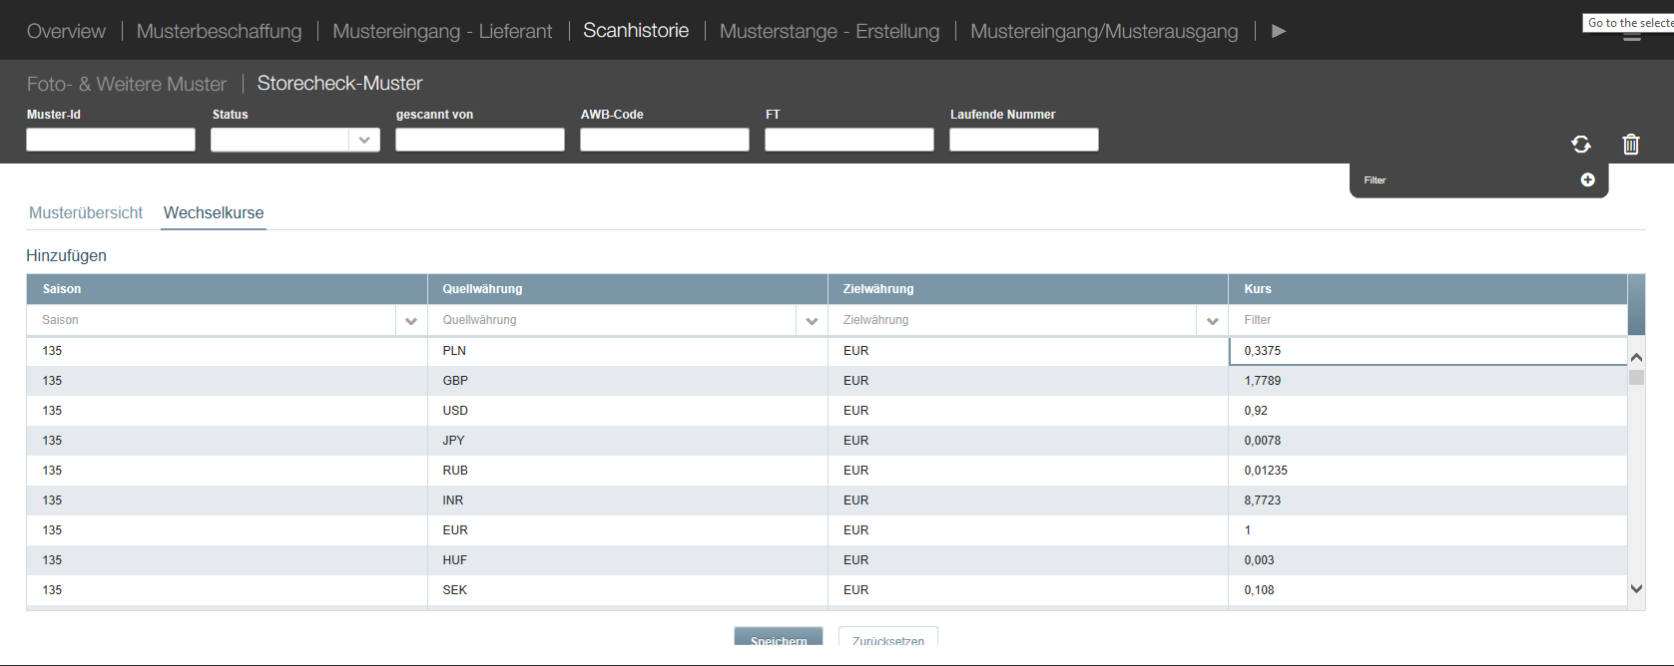

- Then I edit some values in factor column
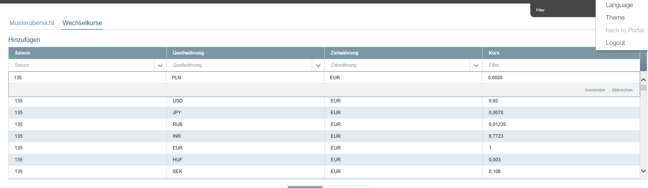

3.I hit enter key validation happens grid refreshes and new values are set.
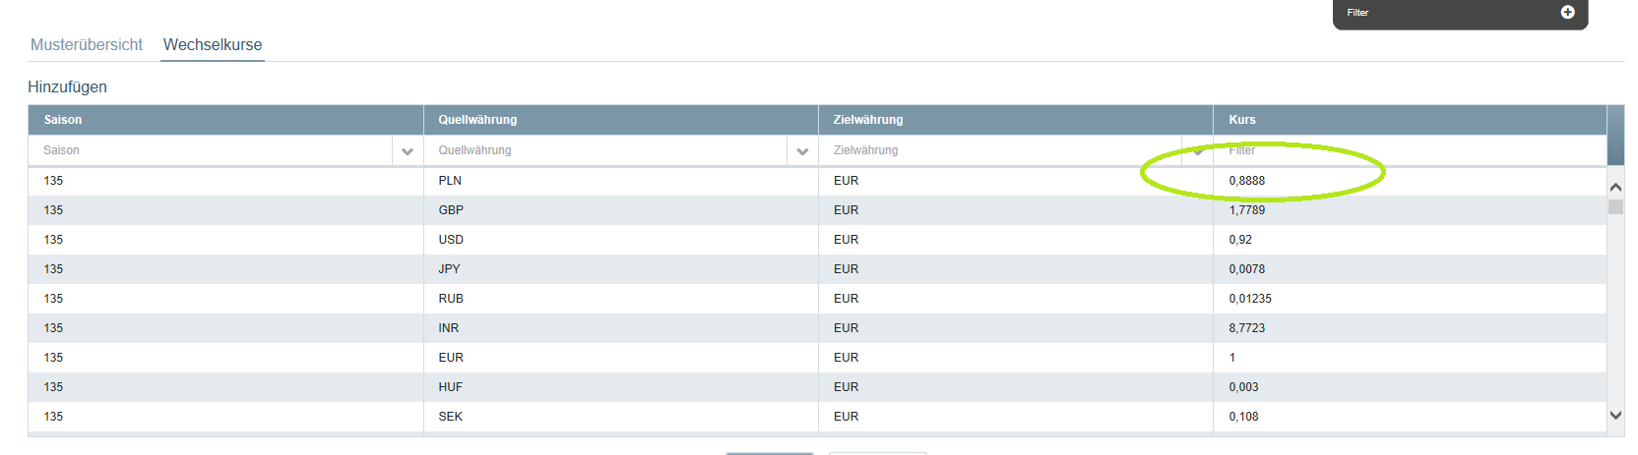

- Again I will go and edit the column like I did in Step 1 and 2 but this time even after hitting the save and refreshing the grid with the new data, it doesn’t refreshes fields on the view.
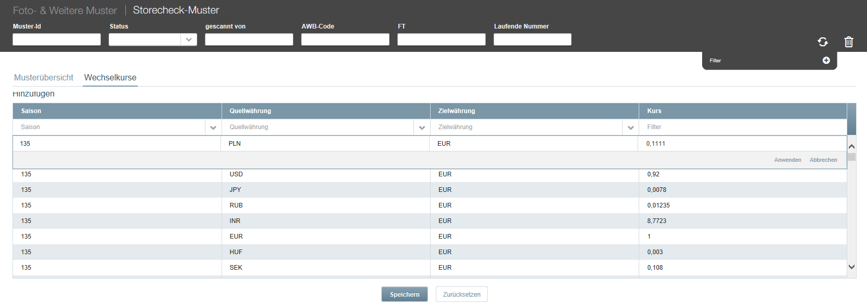

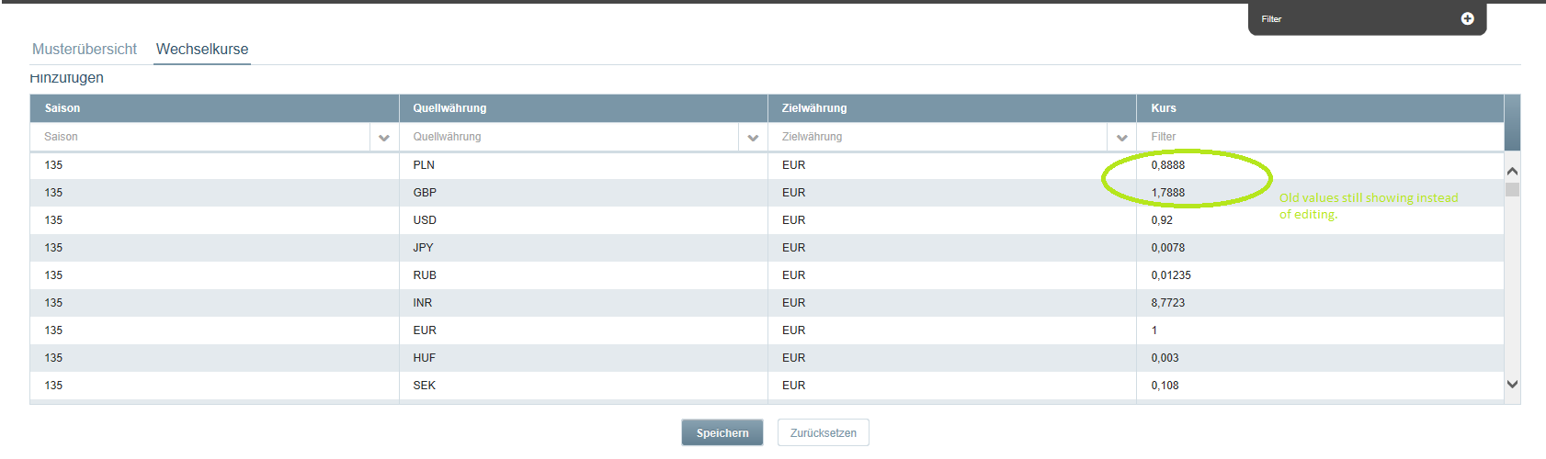
But now that I open the column’s editor again then it will show the value which I edited last time.

