In Chrome:

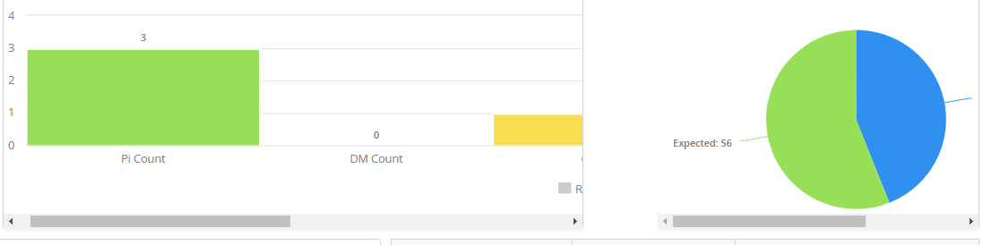

In IE:
In Firefox :

