Login form:
User logging app with user id: VNB02159
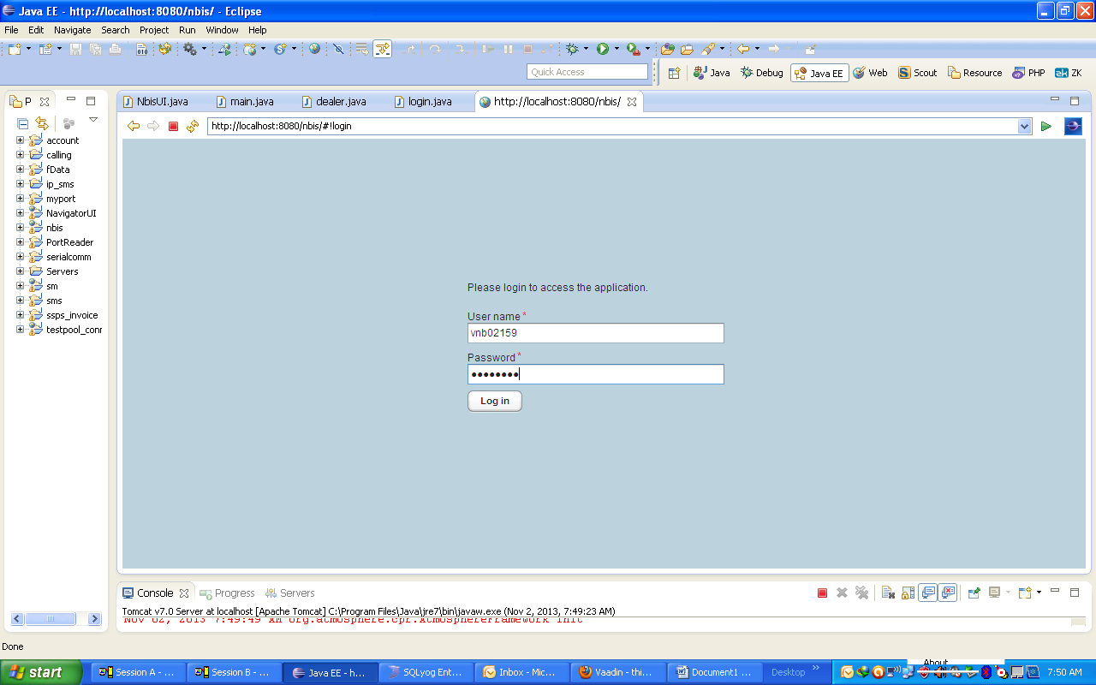
After that user click left side tree menu with function “Work With Dealer”
Then “Work With Dealer” from will show on right side as image below
Next step user click on item listview to revise data
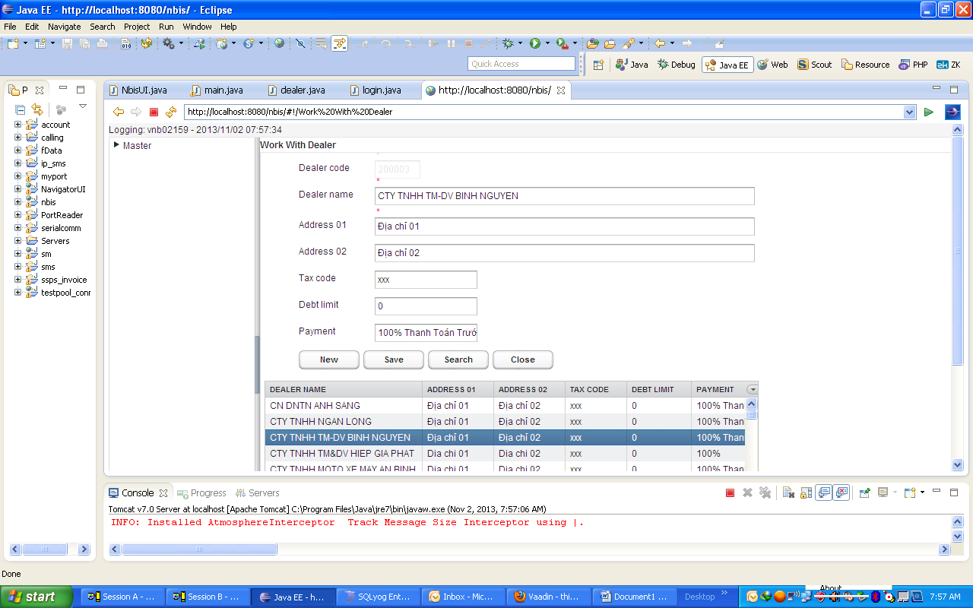
While user VNB02159 is working on “Work With Dealer” then user VNB01608 logging app

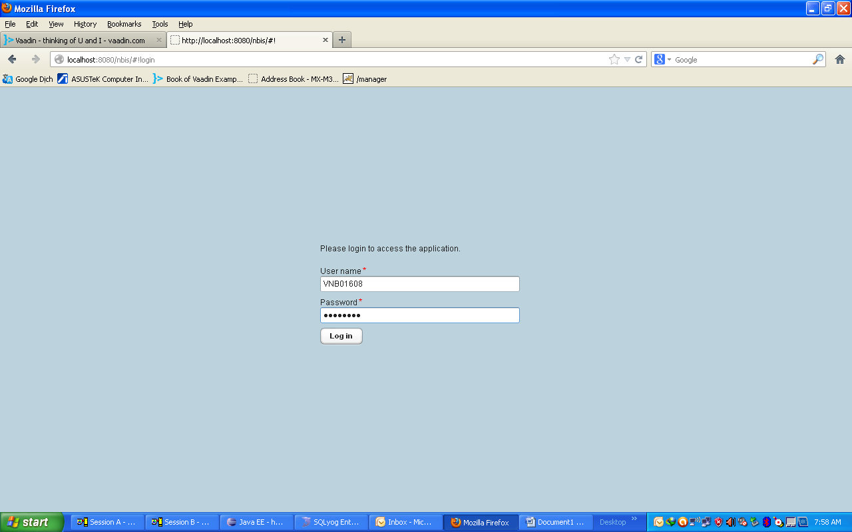
And also click left tree menu “Work With Dealer” “Work With Dealer” from will show right side
While user VNB01608 working on item of listview then user VNB02159 cannot click item on listview (dealer.class)
So that, I would like you to help me how to fix this case
Thanks & Best regards
Tuan Le Van

